 | 2, LEBUH ACHEH, GEORGE TOWN  10300 GEORGE TOWN  PULAU PINANG  PENILAIAN AKHIR AMALI
PROGRAM’S CODE & NAME | J620-002-4:2020 FRONT-END SOFTWARE DEVELOPMENT
LEVEL | 4 (FOUR)
COMPETENCY UNIT NO. AND TITLE | J620-002-4:2020-C02: WEB APPLICATION WITH THIRD PARTY API DEVELOPMENT
WORK ACTIVITIES NO. AND STATEMENT | - PREPARE WEB APP DEVELOPMENT REQUIREMENTS.  - INTEGRATE FRONT-END CLIENT WITH DATA SOURCE.  - VERIFY SUCCESSFUL API INTEGRATION.  - WEBSITE ACCESSIBLE GLOBALLY.
CODE NO. | J620-002-4:2020-C02/PA(1/1) | Page: 1 of
NAME
IC NUMBER
DATE
DURATION | 3 hours | MARKS: / 100%
______________
SIGNATURE OF PEGAWAI PENILAI
KERTAS PEPERIKSAAN INI DISAHKAN OLEH JAWATANKUASA KELULUSAN SOALAN

Instructions to the candidate:
Write your name and IC number in the space provided.
  - Candidates shall only start reading the questions when they are allowed to do so.
  - Answer all questions.
  - No notes were allowed in the examination hall unless informed to do so.
  - Cheating is prohibited.
  - You cannot bring this question paper out from this hall.
  - You shall not use the Internet unless you are about to submit your work.
  - Candidates must complete the task given in the time provided.

THIS PAPER CONSISTS OF PRINTED PAGES.

SECTION A:
TITLE: BUILD A REACT GAME LIST APP WITH DYNAMIC FILTERS, SEARCH AND SORTING.

A. TASK: Your primary task is to create a React app that displays a list of Games. The list should dynamically interact with a provided back-end to support filtering, searching, and sorting based on the data received from the server.

B. INSTRUCTIONS:
- Begin by downloading the project files from the provided link: https://bit.ly/b17-cu2-pa. There will be two zipped files containing the necessary front-end and back-end project. After downloading these files, unzip them.
- Project Structure:
  - cu2_b17_pa_react-qv: This folder contains the React app you will work on.
  - cu2_b17_pa_express-main: This folder contains the Express.js back-end.
DO NOT MODIFY the contents of this folder.
- Setup and start the development environments:
  - Open both folders in your Visual Studio Code.
  - Run the npm install command in each folder to install all required packages.
  - Start the back-end server by running the npm start command in the cu2_b17_pa_express-main folder.
  - Then, start the front-end development server by running the npm run dev command in the cu2_b17_pa _react-qv folder.
- Development Instructions:
  - Focus your development within the cu2_b17_pa _react-qv folder.
  - The back-end API will handle all filtering, sorting, and searching. Your front-end should be designed to send appropriate requests to the API and handle the responses to update the UI dynamically.
  - Look for sections in the code marked with the comment "INSTRUCTION:" in the cu2_b17_pa _react-qv folder. Complete the tasks specified at each of these markers.

C. DRAWING, DATA, AND SCHEDULE:

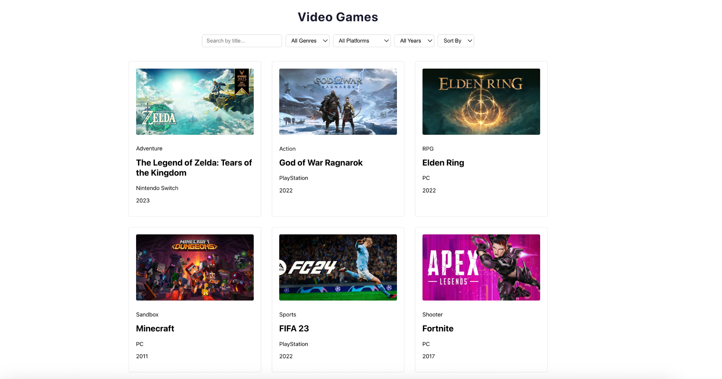
Figure 1: The view of the Games in 3 columns grid format. Each column contains its Title, Genre, Type and Year.
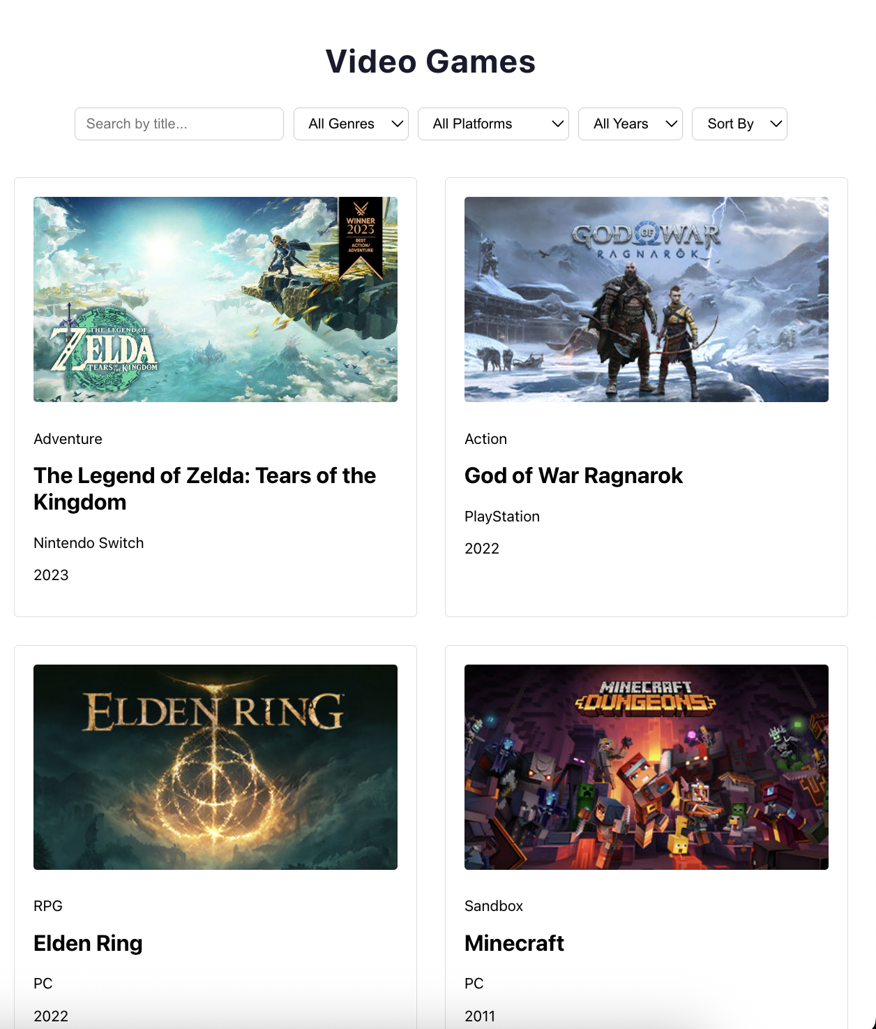
Figure 2: The tablet view of the Games (2 columns per row)
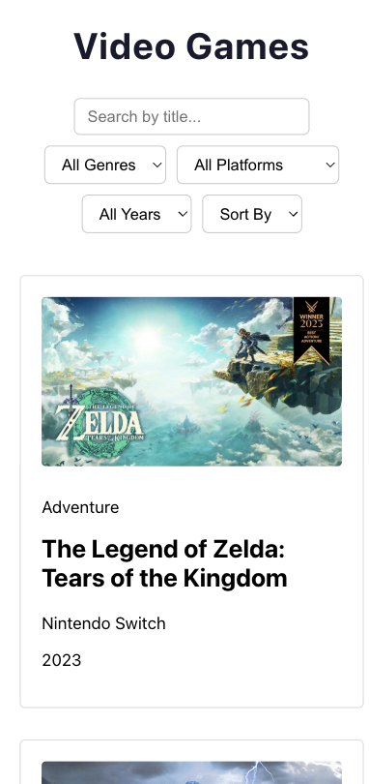

Figure 3: The mobile view of the Games (1 column per row)

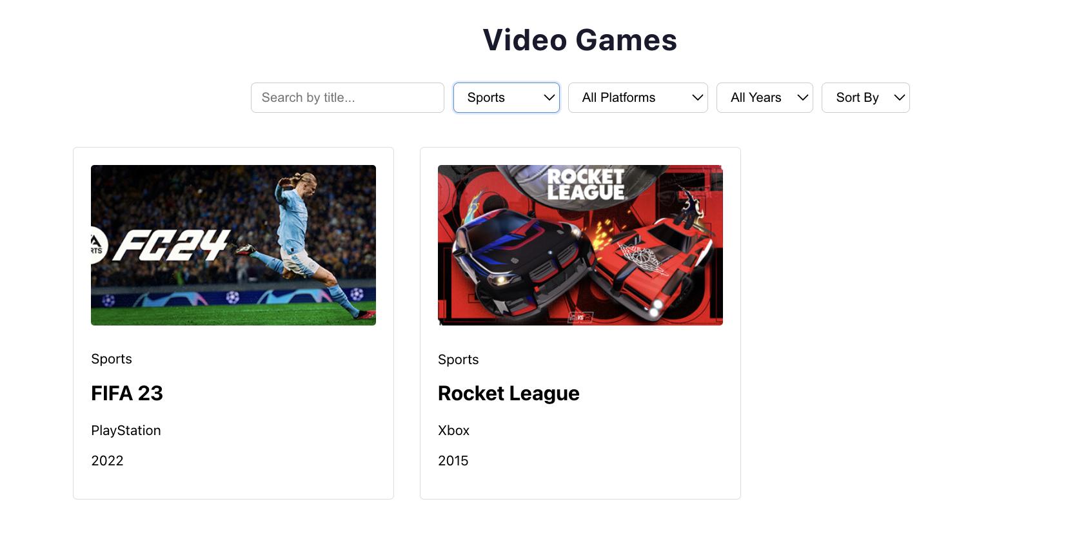

Figure 4: Filtered by genre (sports)
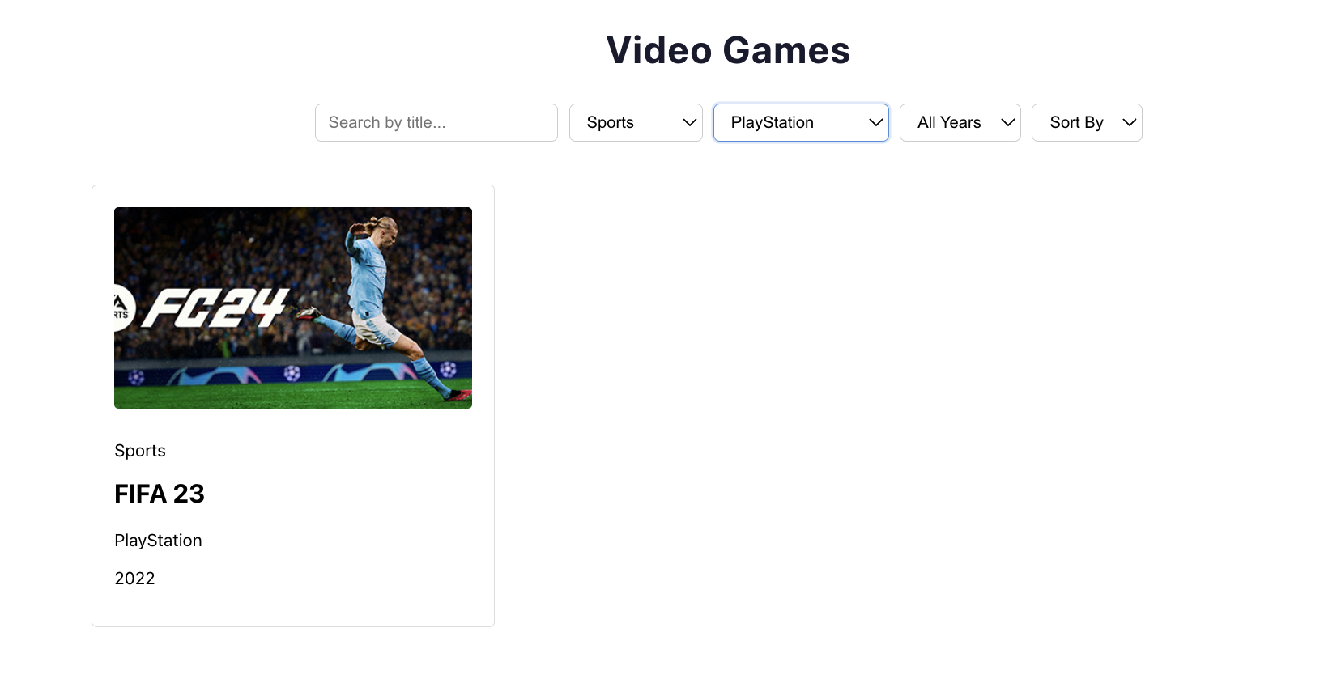

Figure 5: Filtered by Type (PlayStation)

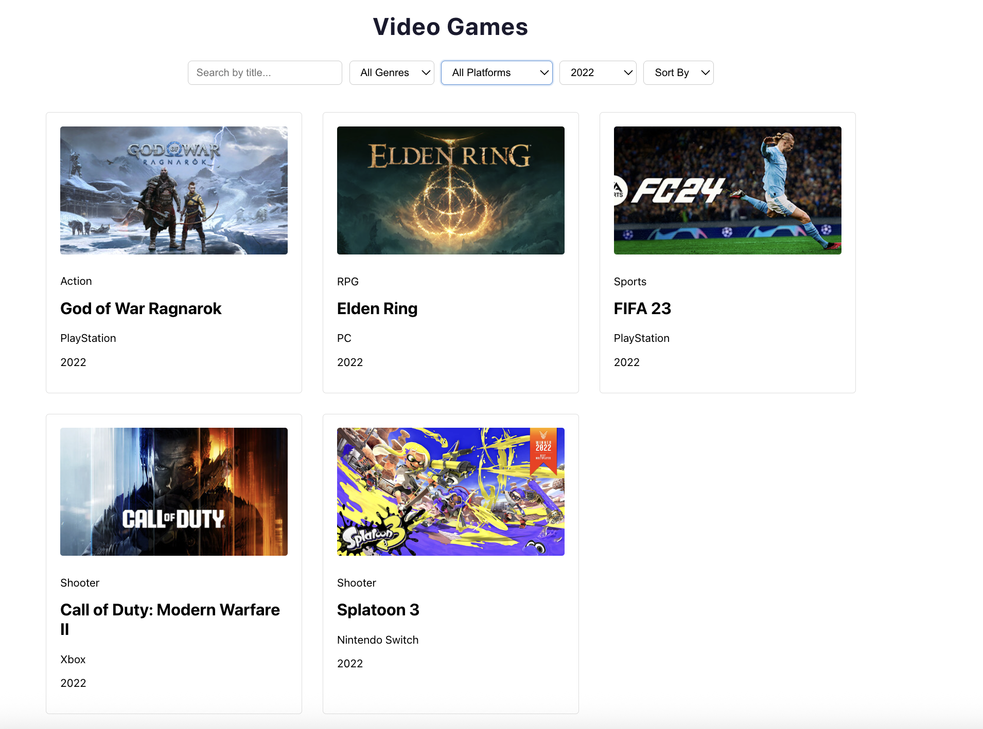

Figure 6: Filtered by Year (2022)

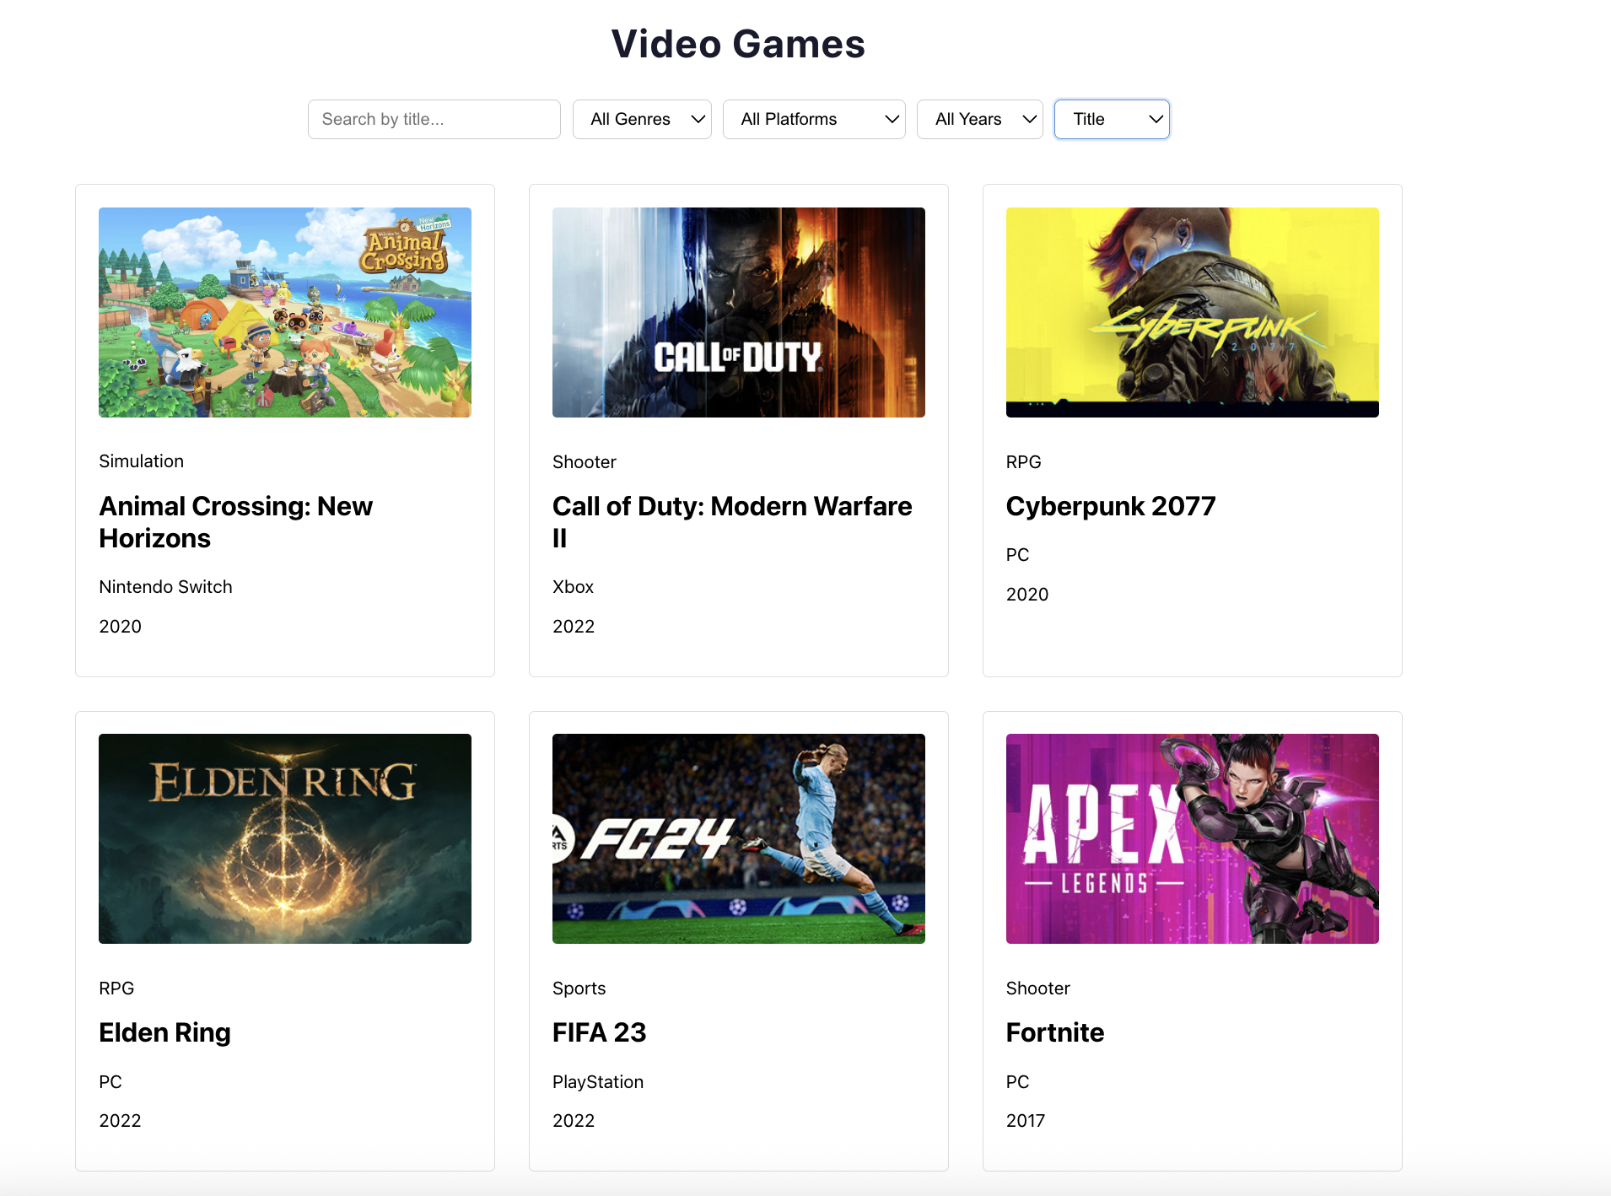

Figure 6: Sort by title

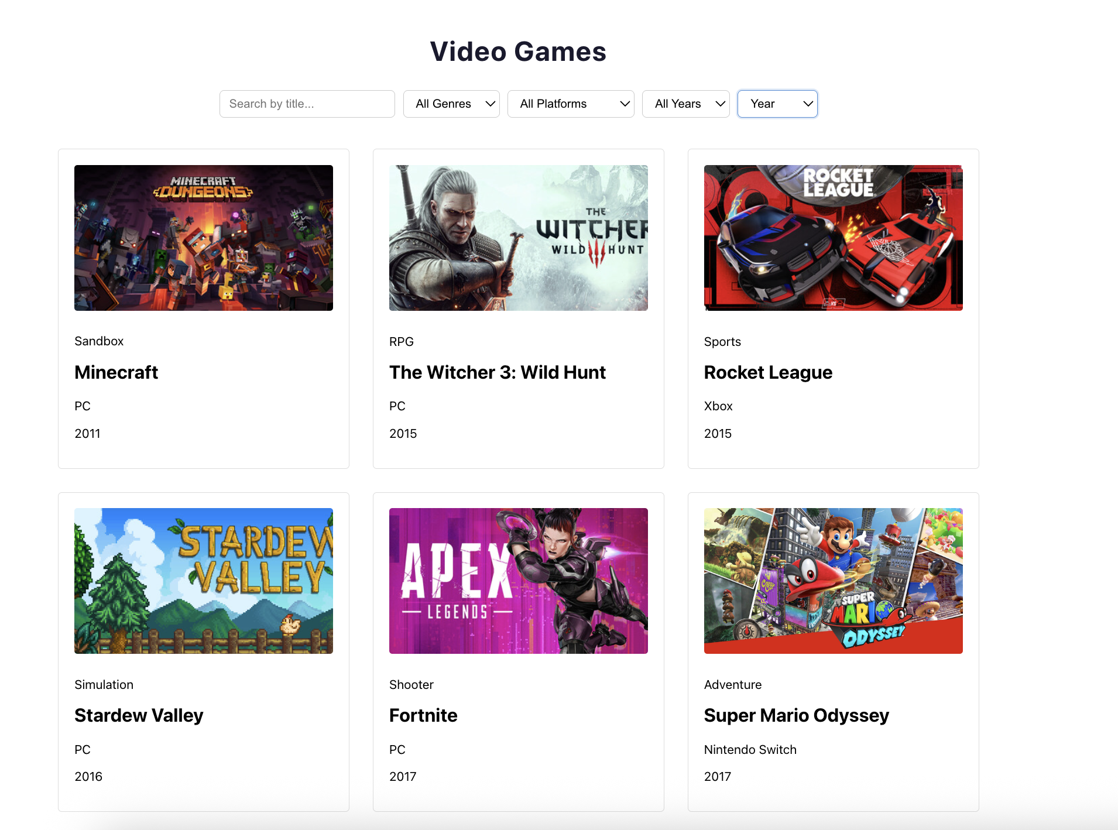
Figure 7: Sort by year

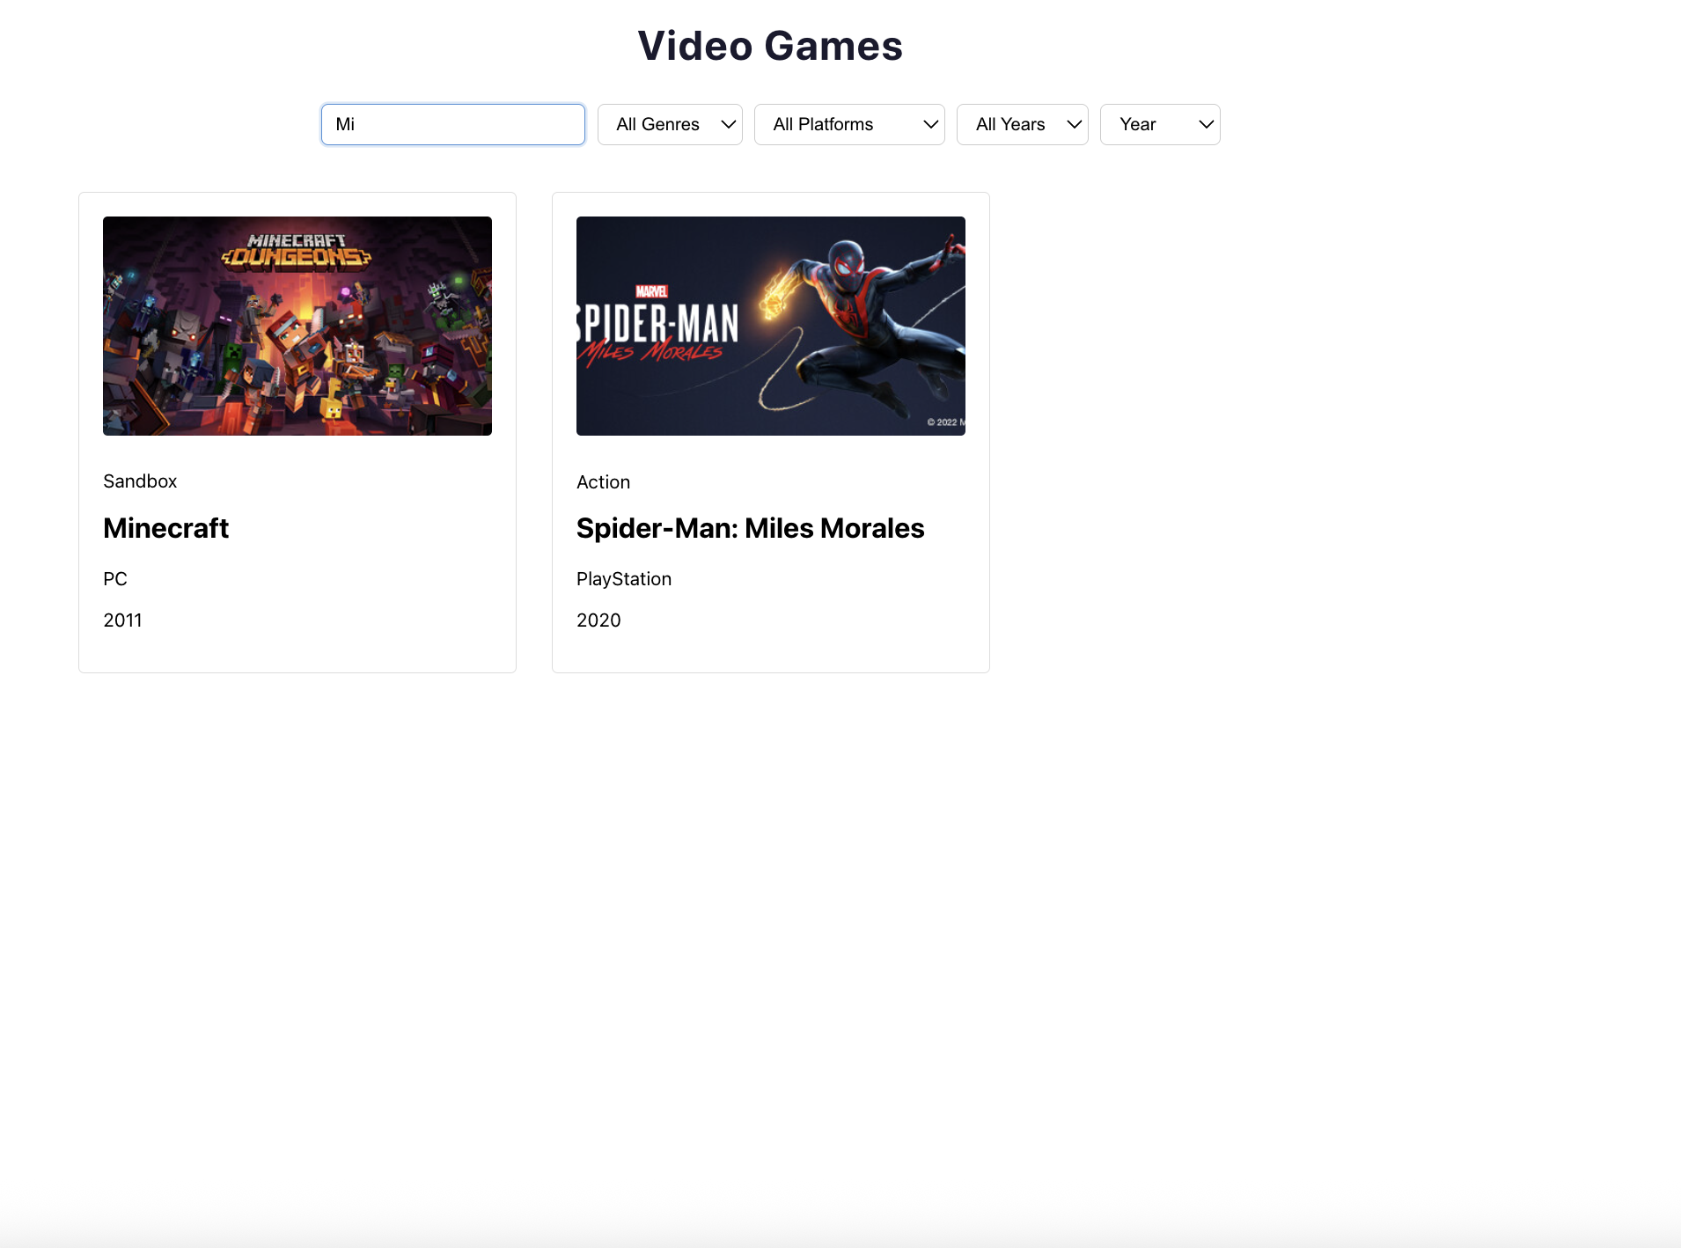

Figure 8: Search by keywords (data)

D. TOOLS, EQUIPMENT DAN MATERIALS

NO. | MATERIALS | QUANTITY  (MATERIALS:CANDIDATE)
- | - | -
NO. | EQUIPMENT | QUANTITY  (EQUIPMENT:CANDIDATE)
1 | Laptop | 1:1
2 | Table | 1:1
3 | Chair | 1:1
4 | Text Editor (VS Code) | 1:1
5 | NodeJS | 1:1

E. DURATION: 3 HOURS

F. ASSESSMENT CRITERIA
The candidate's performance will be assessed according to the following criteria:
- Critical task:
  - Display List: Render a 3-column grid layout that shows the different types of games. Each card should display the Games title, genre, type, and year.
  - Dynamic Filtering: Implement a dropdown that allows users to filter game’s based on their genre, fetched dynamically from the back-end.
  - Responsive Design: Ensure the design is responsive and works well on various screen sizes.

- Task Process:
  - Sort Functionality: Add options to sort games either by title or year using a dropdown menu. The sorting should be requested from and processed by the back-end.
  - Search Capability: Include a search box that allows users to find games by title. The search queries should be processed by the back-end to return relevant results.
  - Filter by Type: Implement a dropdown that allows users to filter game’s based on their type (pc, xbox , playstation,nintendo switch).
  - Filter by Year: Implement a dropdown that allows users to filter games based on their year.
  - User Interface Design: Develop a user interface that is visually appealing, intuitive, and user-friendly, demonstrating good UI/UX principles.
- Task Outcome:
  - Code Quality: The code should be clean, well-commented, efficient, and adhere to modern best practices in React development.

- Attitude/Safety/Environment
  - Submit the solution according to the guidelines.
  - Attend the assessment on time.

Performance Assessment Scheme:
Name of Candidate: |  |  | No. IC:
Start Time: End Time: |  |  | Date:
Marking scale:
0=Underperform/Wrong; 1=Unsatisfactory ; 2=Satisfactory ; 3=Above Expectation

Marking Calculation:
% The weighting will be determined by the expert who developed the question

Section | ASSESSMENT CRITERIA |  |  |  | MARKS
1. | Critical Task (50%) |  |  |  | Mark a (/) on the acceptable and non-acceptable on the following critical task.
 |  |  |  |  | Acceptable |  | Non-acceptable
 | 1.1 Completed the 3-column grid layout that shows the games list. Each card should display the game's title, genre, type, and year.
 | 1.2 Completed the “Filter by ” dropdown which allows users to filter game’s list based on their genre, fetched dynamically from the back-end.
 | 1.3 Completed the responsive design for the grid so that it can be adjusted across all devices—3 columns for desktop, 2 for tablet, and 1 for mobile
 | (*Critical criteria: 50 marks will be given if the above criteria task was performed. 0 marks will be given if any of the criteria tasks were not carried out.)
 | Marks obtained (%) |  |  |  | 50
2. | Task Process (30%) |  |  |  | % Weightage |  | MARKS
 | 2.1 Sort Functionality
 | - Sorting works flawlessly for both titles and year. The sorting is requested and processed by the back-end. |  |  | 3 | 5%
 | - Sorting mostly works but has minor issues |  |  | 2
 | - Sorting has significant issues affecting its utility |  |  | 1
 | - Sorting does not function at all |  |  | 0
 | 2.2 Search Capability
 | - The search box flawlessly filters games based on their title. The search queries are processed by the back-end to return relevant results. |  |  | 3 | 5%
 | - The search box mostly works but has minor inaccuracies |  |  | 2
 | - The search box has significant issues, affecting its utility |  |  | 1
 | - The search box does not function |  |  | 0
 | 2.3 Filter by Types
 | - Filter by type that interacts with the back-end to allow users to filter game’s based on their type (pc,xbox, playstation, nintendo switch) functions as expected |  |  | 3 | 5%
 | - Filter by type mostly works but may have minor issues |  |  | 2
 | - Filter by type has significant issues, affecting its utility |  |  | 1
 | - Filter by type does not function at all |  |  | 0
 | 2.4 Filter by Year
 | - Filter by year that interacts with the back-end to allow users to filter games based on their year functions as expected |  |  | 3 | 5%
 | - Filter by year mostly works but may have minor issues |  |  | 2
 | - Filter by year has significant issues, affecting its utility |  |  | 1
 | - Filter by year does not function at all |  |  | 0
 | 2.5 User Interface Design
 | - Excellent user interface design, featuring exceptional visual appeal, intuitiveness, and a high degree of user-friendliness. |  |  | 3 | 5%
 | - Good user interface design, displaying visual appeal, intuitiveness, and a satisfactory level of user-friendliness. |  |  | 2
 | - Basic user interface design with some visual appeal and intuitiveness, but improvements are needed in terms of overall user-friendliness. |  |  | 1
 | - Poor user interface design, lacking visual appeal, intuitiveness, and overall user-friendliness. |  |  | 0
 | Marks obtained (%)
3. | Task Outcome (15%)
 | 3.1 Code Quality
 | - The code is exemplary: readable, efficient, and adheres to best practices |  |  | 3 | 10%
 | - The code is mostly good but has minor readability or efficiency issues |  |  | 2
 | - The code has significant readability or efficiency issues |  |  | 1
 | - The code is unreadable or inefficient, failing to meet basic coding standards |  |  | 0
 | Marks obtained (%)
4. | Attitude/ Safety/ Environment (5%)
 | 4.1 Submit the solution according to the guideline
 | - The solution is submitted in full accordance with the guidelines, demonstrating exceptional attention to detail and adherence to assessment requirements |  |  | 3 | 3%
 | - The solution is submitted mostly in accordance with the guidelines, demonstrating satisfactory compliance with assessment requirements and minor deviations |  |  | 2
 | - The solution is submitted with significant deviations from the guidelines, demonstrating an unsatisfactory understanding of the assessment requirements |  |  | 1
 | - The solution is submitted without regard for the guidelines or not submitted at all, demonstrating a lack of understanding or commitment to the assessment requirements |  |  | 0
 | 4.2 Attend the Assessment on Time
 | - Arrives well ahead of the scheduled assessment time, demonstrating exceptional punctuality and time management skills |  |  | 3 | 2%
 | - Arrives slightly late (within 10 min) for the scheduled assessment, demonstrating satisfactory punctuality and time management skills. |  |  | 2
 | - Arrives slightly late (more than 15 min) for the scheduled assessment, demonstrating unsatisfactory punctuality and time management skills. |  |  | 1
 | - Arrives significantly late (more than 30min) or does not attend the scheduled assessment, demonstrating a lack of punctuality and time management skills. |  |  | 0
 | Marks obtained (%)
Total Marks Combine
(Section 1 + Section 2 + Section 3 + Section 4)
Assessment Result
MARKS: |  | SHOWN/ NOT SHOWN
FEEDBACK OF PEGAWAI PENILAI
Signature of Pegawai Penilai  Name |  | DATE

